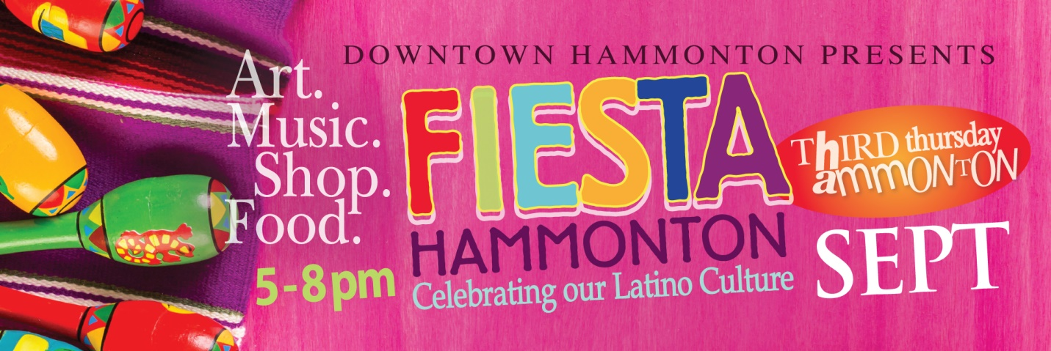
Celebrating…. Latino Art, Crafts, Fashion, Poetry & Music

ArtWalk Stage by Annata Wine Garden:
Spanish Singer Melenis Velez performance
Spanish Poetry Reading- Honduran Poet Andrea Flores and Peruvian Poet Jim Paul Bacon

Central Ave:
Authentic Piñatas Display and Process
- DJ Cruz

Front Street:
Blueberry Farm Workers Story Display
DJ Barco
High School Senior Display

South Second St.
Traditional wardrobe from Hispanic Countries
Frida Khalo Kids Crafts
Migrant Workers Story Display
Hispanic Countries Information Displays
Infographic Video from Hispanic countries.

Special guest, Marichi Singer, ROSITA

**Flags of Hispanic Countries along Bellevue Ave to celebrate Hispanic Heritage Month (Sept 15- Oct15)

Activities were coordinated and partially funded by:

Downtown Hammonton Food, Drink & Shopping Specials
Annata Wine Bar (216 Bellevue Ave) Try one of the delicious Annata flavored margaritas!

Casciano Coffee Bar & Sweetery (212 Bellevue Ave) Stop by for Latino drink and food specials as well as complimentary Tres Leches Cake sampling with any drink order.

El Nuevo Mariachi Loco (101 Bellevue Ave) Listen to live music with Ricardo Ceballos while you dine. Check out our Burritos Rancheros. BYOB.

Fiesta Mexicana (327 12th St) Offering 10% OFF all food and drinks. Feature food that night is fajitas and shrimp a la diabla.
Fruta Mex (1 12th St) $1.00 OFF Mexican corn, “Elote”

Hammonton Arts Center (10 S Second St) Come celebrate with us and make festive paper flowers. FREE materials and instruction provided. Kids and adults are welcome to participate.

Mannino’s Cannoli Express (220 Bellevue Ave) Check out our Churro Cannoli. Complimentary Pineapple Refresher and 10% OFF any order from 5-8pm.

New Era of Mystical Trends (8 Central Ave) ** Stop by to say hello to the new downtown business. Lots of specials… 25% OFF newest avid readers’ favorite, “The daring tale of a man becoming an angel “Ascension!”.15% OFF the first schedule crystal bed healing session.10% OFF Life Coaching session.5% OFF any spiritual products such as sage, incense, soap, cleansers. 5% OFF intuitive reading session.

Noyes Museum at Kramer Hall, Stockton University (30 Front St) Exhibit featuring Ada Trillo, “If Walls Could Speak”. Reception: 5pm-7pm

Rita’s Kitchen & T-bone Taco (7 N Egg Harbor Rd) will feature a new dish on her menu el campechano $12 and enchiladas with shrimp or fish. FREE fresh fruit water with every dish
SaDee’s Clothing Boutique (210 Bellevue Ave) 20% OFF purchase. Buy 2, get 1 FREE sale styles.
Tales of the Olive (218 Bellevue Ave) Visit and sample some Spicy and Sweet Salsas (individually packaged) for your safe convenience. Take a chance on winning a "Fiesta Chip -N- Dip" Gift Basket worth a $100.00 value starting Saturday, 9/12 thru Thursday, 9/17.

Three 3's Brewing Co (50 13th St) will be open on Thursday from 5-8. We welcome everyone to bring their snacks and join us in the Beer Garden. No reservations necessary. 14 Beers on tap and plenty of take-out options!
Vinyl Brewing (300B 12th St) Grab your Latin American cuisine from one of the many Downtown eateries and enjoy it in the beer garden or in the tasting room. Have a favorite Latino record? We will play it for you!

*Tune in to Art Club LIVE on Facebook- 7pm https://www.facebook.com/artclubhammonton

