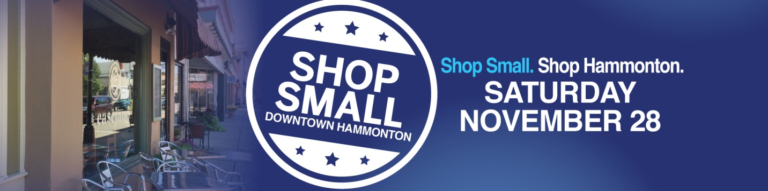

Allisonanne Studios (9 S Washington St) Unique Portraits with Santa (by appointment only) and gift certificate specials all on Nov 28 only. Call the studio 609-828-8331 to inquire!

Ananta Wine Bar (216 Bellevue Ave) Free $25 gift card for every $100 spent in gift cards.” Retail wine” clean out… with extreme discounts.

Breadheads Bakery (14 S Second St) Fresh baked bread served from 10 am to 3.
Casciano Coffee Bar (212 Bellevue Ave) Gift Card Bonanza! Buy 3 gift cards, get 4th free! (All same value) Fri, Sat & Sun!

Fiesta Mexicana (327 12th St) Offering 10% OFF any gift card purchases, for the holidays.
Mannino’s Cannoli Express -Place your holiday orders and receive 10% OFF your total purchase. Complimentary mini with any purchase. Take a shot at one of our raffles for free cannoli, coffee, pie, cookies & more! (1 ticket per customer for every $5 spent)

New Era of Mystical Trends (8 Central Ave) 25% OFF Any large crystal purchase. 25% OFF the book, “Ascension!”,25% OFF multi scheduled crystal healing session,15% OFF the first schedule crystal bed healing session, 10% OFF Life coaching session, 10% OFF any $20.00 or more purchase of crystals or stones, 5% OFF any spiritual products such as sage, incense, soap, cleansers, 5% OFF intuitive reading session

Ohana Bar (10 E Central Ave) Offering a FREE tumbler with the purchase of a $20 gift card.

SaDee’s Clothing Boutique (210 Bellevue Ave) 30% OFF entire store.
Tales of the Olive (218 Bellevue Ave) Buy 3 Bottles Get 1 FREE!! Many savings... Shopping local, shopping Small Business. We appreciate your support.
Three 3’s Brewery (50 13th St) Stock up for the holidays with Three 3's Mix and Match Case Specials! Two deals to choose from. Onsite Brewery orders only. Saturday 1-9, Sunday 1-7.1) 𝐌𝐢𝐱 𝐚𝐧𝐝 𝐌𝐚𝐭𝐜𝐡 𝐂𝐚𝐬𝐞 𝐒𝐩𝐞𝐜𝐢𝐚𝐥 - (6) 4-packs for $80*. 2) 𝐄𝐙 𝐃𝐫𝐢𝐧𝐤𝐢𝐧 𝐂𝐚𝐬𝐞 𝐒𝐩𝐞𝐜𝐢𝐚𝐥 - (3) 4-packs of EZ haZE Ale and (3) 4-packs of Halfway to Helles Lager for $70*some restrictions apply
Toy Market (200 Bellevue Ave) Virtual Small Business Saturday Weekend. Enjoy 20% Off any One Item. SHOP SMALL on Small Business Saturday, Sunday or Cyber Monday. Valid in store or online 11/28/20-11/30/20 *excludes LEGO
Vintage Betty’s (128 Bellevue Ave) 50% OFF all dishes and glassware except Pyrex. 20% OFF everything in the store with purchase of $10 or more except… coins, jewelry, and sports jerseys. Sales cannot be combined with other offers.
Vinyl Brewing Co- (300 B 12th St) Celebrate the giving season & drink small! Take advantage of our Gift Card Special $100 for $80, $50 for $40 and $25 for $20!

Music provided by DJ Cruz

