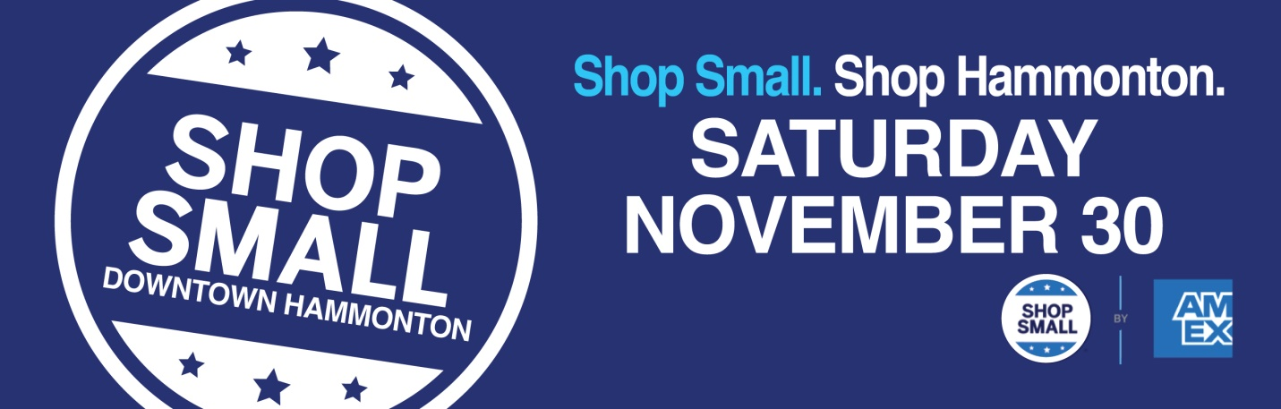
Be a Part of Something Special!
Allisonanne Studios, 9 S Washington St-Give the Gift of Family Portraits. Receive $100 gift card with $300 gift card purchase. Receive $200 gift card with $500 gift card purchase. Offer ends Dec 3.
Annata Wine Bar, 216 Bellevue Ave- “Retail Wine Clean Out” with extreme discounts. FREE $25 gift card for every $100 spent in gift cards.
Antique Marketplace, 109 12th St- Receive a gift with any purchase. Find “Francis the AMP Elf” and receive a special gift. Offered from now until Christmas.
Bellevue Bagel, 208 Bellevue Ave- Buy $50 in gift cards, get $10 gift card for yourself.
Casciano Coffee Bar & Sweetery, 212 Bellevue Ave- Buy 4 Gift Cards and get 5th FREE (at same price)
Chroma Beauty Bar, 5 S Second St- 20 % OFF all retail clothing and products. Purchase a $100 gift certificate and get a $10 gift certificate for yourself.
David Charles, 516 12th S Second St- The more you SPEND, the more you EARN. Earn promotional gift certificates when you make a purchase of $150 or more.

Eastern Phoenix, 125 Bellevue Ave- 20%OFF for all sushi rolls.

El Nuevo Mariachi Loco, 101 Bellevue Ave- FREE Flan with $30 purchase.

Fitness Mogul, 103 N Egg Harbor Rd- Offering (4) 30 minute private training sessions for $148, a 5 class card for $70+tax and 3 months of unlimited group training for $357+tax. Stop in between 9 am - 1 pm to purchase a membership and take a tour of our brand new 4,600 Sq Ft private training facility. We are celebrating 8 years of changing people's lives this January 2020.

Hammonton Arts Center, 10 S Second St- Check out our, “Featured Artist Sale”.

Hollywood Dog Salon, 20 12th St- Pamper your pet with this Holiday Special. Stop in to book an appointment and get $5.00 OFF.
Ohana Juice Bar, 10 Central Ave- Get a “Nice & Nutty”, 50%OFF with the purchase of a gift card.

Mannino’s Cannoli Express, 220 Bellevue Ave- FREE “Bag of Cookies” with every order and 6 raffle giveaway boxes; each containing a gift card or FREE menu item.
Next Door, 212 Bellevue Ave-Opening Reception for Marie Natale, 10 to 2
SaDee’s Clothing Boutique, 210 Bellevue Ave- 30% OFF sale (jewelry excluded).

Studio 21 Brow Bar, 21 Central Ave-“Gift Card Special”- Purchase $100 for only $80. Limit 4 per customer. 20% OFF any Studio 21 brow cosmetics.

Tales of the Olive, 218 Bellevue Ave- Visit us today with a receipt from any other store in town ($10.00 or more value) and receive 15% OFF your purchase. Also, BUY 3, get 1 FREE. This offer cannot be combined. Enjoy FREE snacks and drinks.
The Hair Lounge, 23 Central Ave- Purchase $100 gift card & get additional $20 hair lounge cash. 25% OFF all in stock retail.

Three 3’s Brewing Co., 50 13thSt. – Purchase $50 in Gift Certificates and get a FREE 32oz Growler. Our fridge is always full with 4-packs to celebrate the Holidays. Need a keg? Check in with us to see what we have available. The list is always changing. Ask about Gift Baskets.

Toy Market, 200 Bellevue Ave. - 20% OFF one item. FREE gift with purchase.

Your Space Yoga Studio, 218 B Bellevue Ave- $5 single yoga class on Saturday 11/30 at 10am. All levels welcome. FREE 30min Guided Meditation at 11:15am. No mat required. Visit us today with a receipt ($10.00 or more value) from any other store in town and receive 10% off your monthly unlimited subscription. See Studio for specific details.
Vinyl Brewing Co., 300 B 12th St- Check in with us and find out about our “7 Weeks of Christmas Special”. Each week there will be a new discount to check off the Craft Beer lovers on your shopping list.
Small Business Saturday is coordinated by MainStreet Hammonton.

